cURL

🌟 Definition
# Source: AI Source: Provided by: [Data Path: Persons Table -> ID Column: 1, Name_En Column: Motasem Essam] -> From: [ChatGPT] on [6/1/2026]
cURL (Client URL) is a command-line tool used to send and receive data over network protocols such as HTTP and HTTPS.
It is commonly used to:
- Test APIs
- Download files
- Upload files
- Send HTTP requests
- Automate web interactions
Official website:
cURL Official Website

🎯 Purpose
# Source: AI Source: Provided by: [Data Path: Persons Table -> ID Column: 1, Name_En Column: Motasem Essam] -> From: [ChatGPT] on [6/1/2026]
- Communicate with web servers
- Test REST APIs
- Send GET, POST, PUT, PATCH, and DELETE requests
- Download files
- Upload files
- Automate network tasks

🔢 Main Uses of cURL

1. 📥 GET Request
# Source: AI Source: Provided by: [Data Path: Persons Table -> ID Column: 1, Name_En Column: Motasem Essam] -> From: [ChatGPT] on [6/1/2026]
🌟 Meaning
Retrieve data from a server or API.
Example
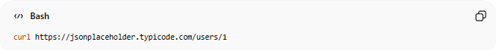
curl https://jsonplaceholder.typicode.com/users/1
Response
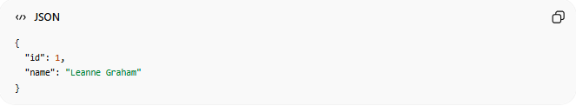
{
"id": 1,
"name": "Leanne Graham"
}

2. ➕ POST Request
# Source: AI Source: Provided by: [Data Path: Persons Table -> ID Column: 1, Name_En Column: Motasem Essam] -> From: [ChatGPT] on [6/1/2026]
🌟 Meaning
Create a new resource by sending data to the server.
Example
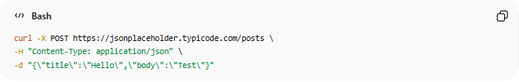
curl -X POST https://jsonplaceholder.typicode.com/posts \
-H "Content-Type: application/json" \
-d "{\"title\":\"Hello\",\"body\":\"Test\"}"
JSON Sent
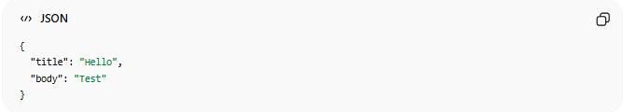
{
"title": "Hello",
"body": "Test"
}

3. ✏️ PUT Request
# Source: AI Source: Provided by: [Data Path: Persons Table -> ID Column: 1, Name_En Column: Motasem Essam] -> From: [ChatGPT] on [6/1/2026]
🌟 Meaning
Replace an existing resource completely.
Example
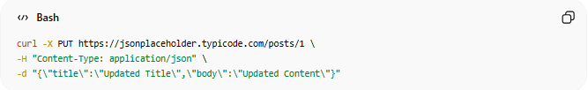
curl -X PUT https://jsonplaceholder.typicode.com/posts/1 \
-H "Content-Type: application/json" \
-d "{\"title\":\"Updated Title\",\"body\":\"Updated Content\"}"

4. 🔧 PATCH Request
# Source: AI Source: Provided by: [Data Path: Persons Table -> ID Column: 1, Name_En Column: Motasem Essam] -> From: [ChatGPT] on [6/1/2026]
🌟 Meaning
Update only part of an existing resource.
Example
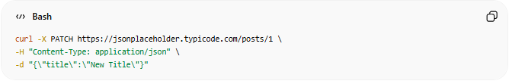
curl -X PATCH https://jsonplaceholder.typicode.com/posts/1 \
-H "Content-Type: application/json" \
-d "{\"title\":\"New Title\"}"
JSON Sent
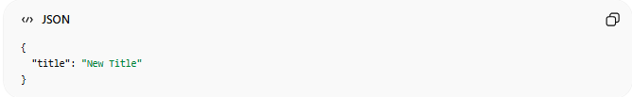
{
"title": "New Title"
}

5. ❌ DELETE Request
# Source: AI Source: Provided by: [Data Path: Persons Table -> ID Column: 1, Name_En Column: Motasem Essam] -> From: [ChatGPT] on [6/1/2026]
🌟 Meaning
Delete a resource from the server.
Example
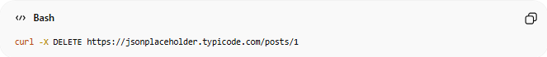
curl -X DELETE https://jsonplaceholder.typicode.com/posts/1

6. 📥 Download a File
# Source: AI Source: Provided by: [Data Path: Persons Table -> ID Column: 1, Name_En Column: Motasem Essam] -> From: [ChatGPT] on [6/1/2026]
🌟 Meaning
Download a file from a URL.
Example
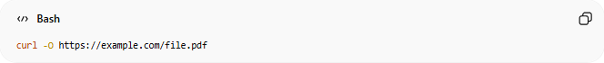
curl -O https://example.com/file.pdf
Result
file.pdf
Downloaded into the current folder.

7. 📤 Upload Files
# Source: AI Source: Provided by: [Data Path: Persons Table -> ID Column: 1, Name_En Column: Motasem Essam] -> From: [ChatGPT] on [6/1/2026]
🌟 Meaning
Send a file from your computer to a server.
Example (Upload a File)
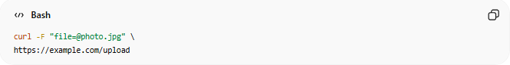
curl -F "file=@photo.jpg" \
https://example.com/upload
What Happens?
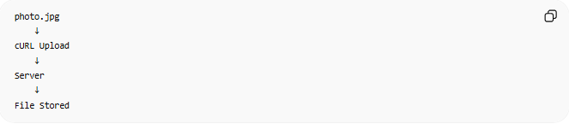
photo.jpg
↓
cURL Upload
↓
Server
↓
File Stored
Common Uses
- Upload images
- Upload documents
- Upload videos
- Submit attachments through APIs

Example (Upload Multiple Files)
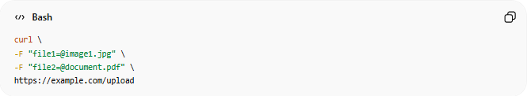
curl \
-F "file1=@image1.jpg" \
-F "file2=@document.pdf" \
https://example.com/upload

8. 🔐 Authorization Header
# Source: AI Source: Provided by: [Data Path: Persons Table -> ID Column: 1, Name_En Column: Motasem Essam] -> From: [ChatGPT] on [6/1/2026]
🌟 Meaning
Send authentication information with the request.
Example (Bearer Token)
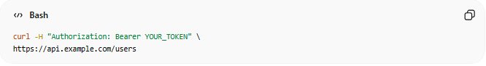
curl -H "Authorization: Bearer YOUR_TOKEN" \
https://api.example.com/users
Example
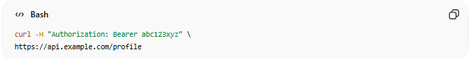
curl -H "Authorization: Bearer abc123xyz" \
https://api.example.com/profile
Common Authorization Types
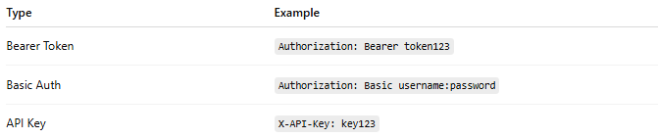
Type | Example
Bearer Token | Authorization: Bearer token123
Basic Auth | Authorization: Basic username:password
API Key | X-API-Key: key123
Used In
- AI APIs
- Payment APIs
- Cloud APIs
- Private APIs
- User authentication systems

9. 💾 Save Response to a File
# Source: AI Source: Provided by: [Data Path: Persons Table -> ID Column: 1, Name_En Column: Motasem Essam] -> From: [ChatGPT] on [6/1/2026]
🌟 Meaning
Store the server response directly in a file.

Save with Custom Filename
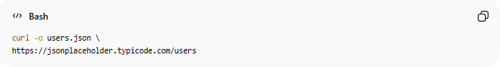
curl -o users.json \
https://jsonplaceholder.typicode.com/users
Result
users.json

Save API Response
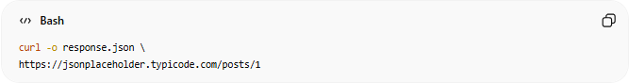
curl -o response.json \
https://jsonplaceholder.typicode.com/posts/1
Result
response.json

Save Website HTML
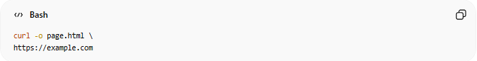
curl -o page.html \
https://example.com
Result
page.html

10. 🤖 Automate Web Interactions
# Source: AI Source: Provided by: [Data Path: Persons Table -> ID Column: 1, Name_En Column: Motasem Essam] -> From: [ChatGPT] on [6/1/2026]
🌟 Meaning
Use cURL inside scripts to automatically interact with websites and APIs without opening a browser.

Example (Check a Website)
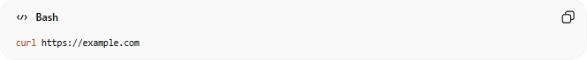
curl https://example.com

Example (Run Every Hour)
Linux Cron Job:

0 * * * * curl https://api.example.com/status
This automatically calls the API every hour.

Example (Download Daily Data)
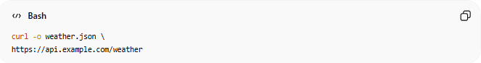
curl -o weather.json \
https://api.example.com/weather
Can be scheduled to run automatically.

Example (API Monitoring)
curl -I https://example.com
Checks whether a website is online by viewing response headers.

🔗 How cURL Works
# Source: AI Source: Provided by: [Data Path: Persons Table -> ID Column: 1, Name_En Column: Motasem Essam] -> From: [ChatGPT] on [6/1/2026]
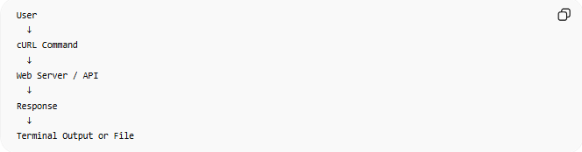
User
↓
cURL Command
↓
Web Server / API
↓
Response
↓
Terminal Output or File

📚 Common cURL Options
# Source: AI Source: Provided by: [Data Path: Persons Table -> ID Column: 1, Name_En Column: Motasem Essam] -> From: [ChatGPT] on [6/1/2026]
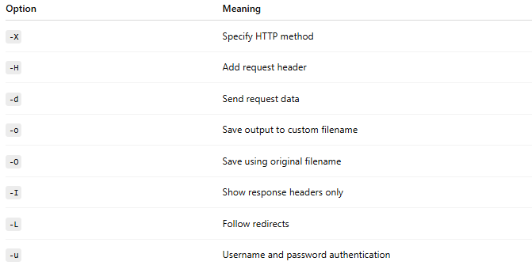
Option | Meaning
-X | Specify HTTP method
-H | Add request header
-d | Send request data
-o | Save output to custom filename
-O | Save using original filename
-I | Show response headers only
-L | Follow redirects
-u | Username and password authentication

⚖️ cURL vs Postman
# Source: AI Source: Provided by: [Data Path: Persons Table -> ID Column: 1, Name_En Column: Motasem Essam] -> From: [ChatGPT] on [6/1/2026]
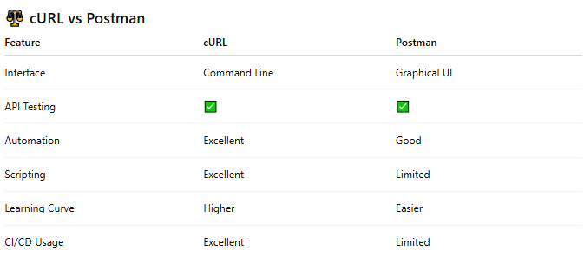
Feature | cURL | Postman
Interface | Command Line | Graphical UI
API Testing | ✅ | ✅
Automation | Excellent | Good
Scripting | Excellent | Limited
Learning Curve | Higher | Easier
CI/CD Usage | Excellent | Limited

🧠 Simple Analogy
# Source: AI Source: Provided by: [Data Path: Persons Table -> ID Column: 1, Name_En Column: Motasem Essam] -> From: [ChatGPT] on [6/1/2026]
Think of cURL as:
📞 A direct phone call to a server
You manually type the request and immediately receive the response.
Postman performs the same job but provides a graphical interface instead of command-line commands.

🧪 Use Cases
# Source: AI Source: Provided by: [Data Path: Persons Table -> ID Column: 1, Name_En Column: Motasem Essam] -> From: [ChatGPT] on [6/1/2026]
- Quick API testing in terminal
- Scripting API calls in bash/Python scripts
- CI/CD pipelines for health checks
- Downloading/uploading files over HTTP/SFTP

Download cURL
# Source: ScreenShot Source: Provided by: [Persons Table -> ID Column: 1, Name_En Column: Motasem Essam] -> Tool: [Automation Table -> ID Column: 16, Name_En Column: Screen Capture] -> From [Site: Google Search: All: cURL] on [6/1/2026]
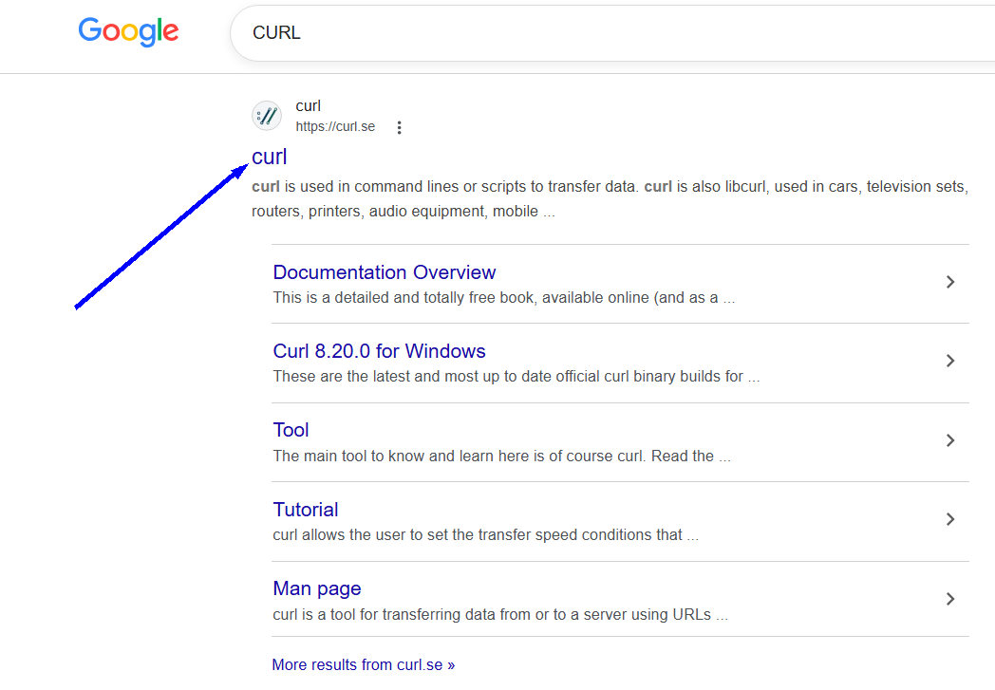


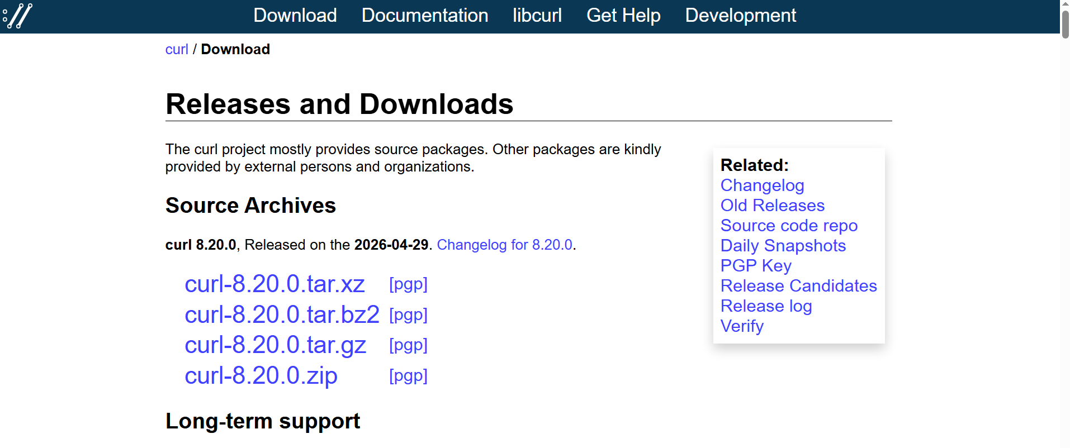
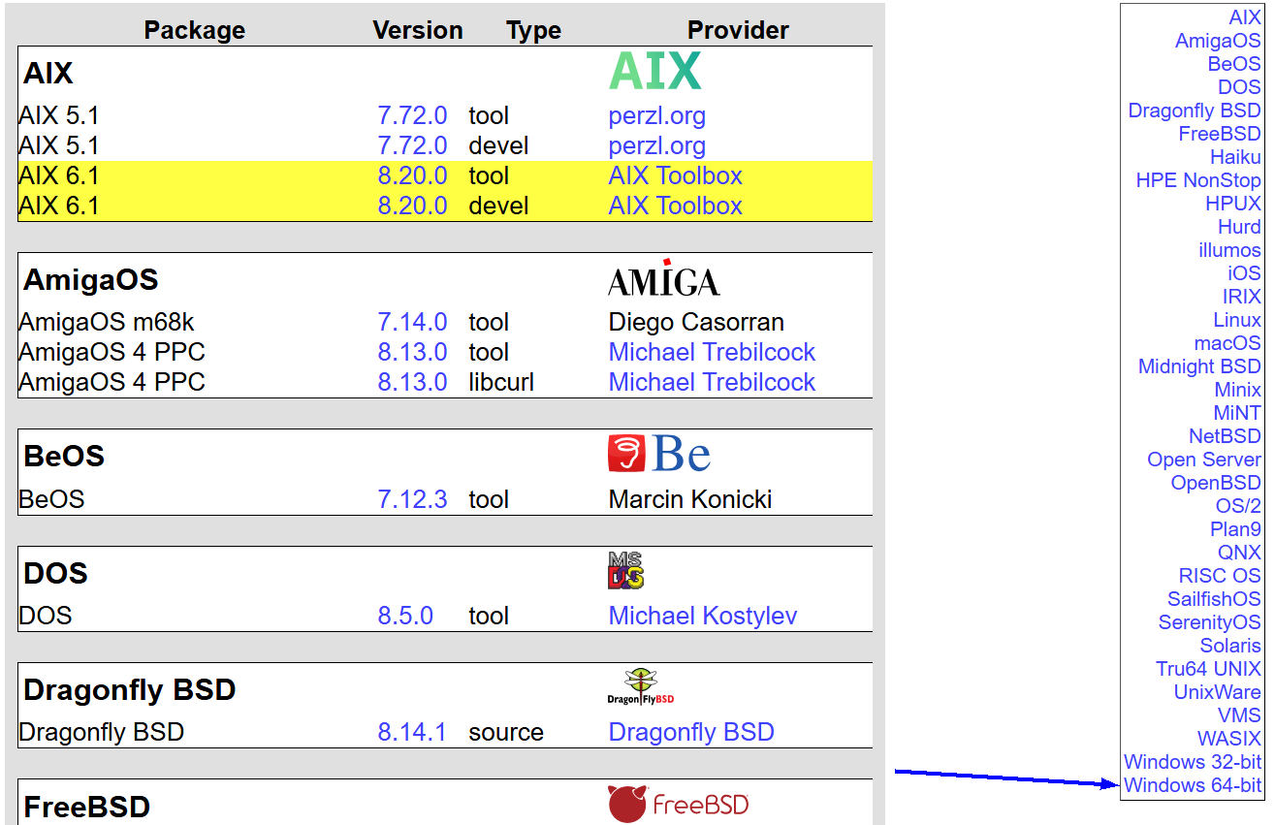
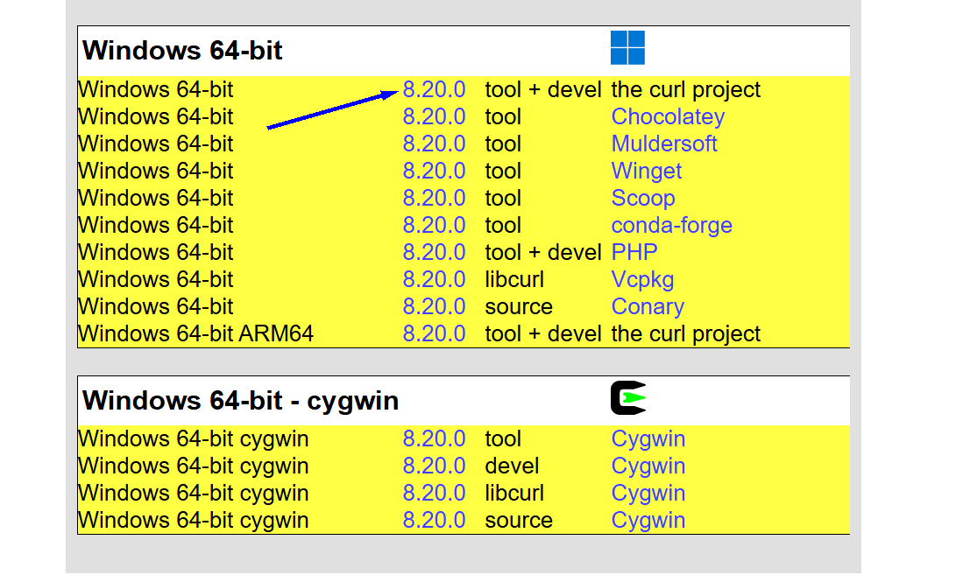
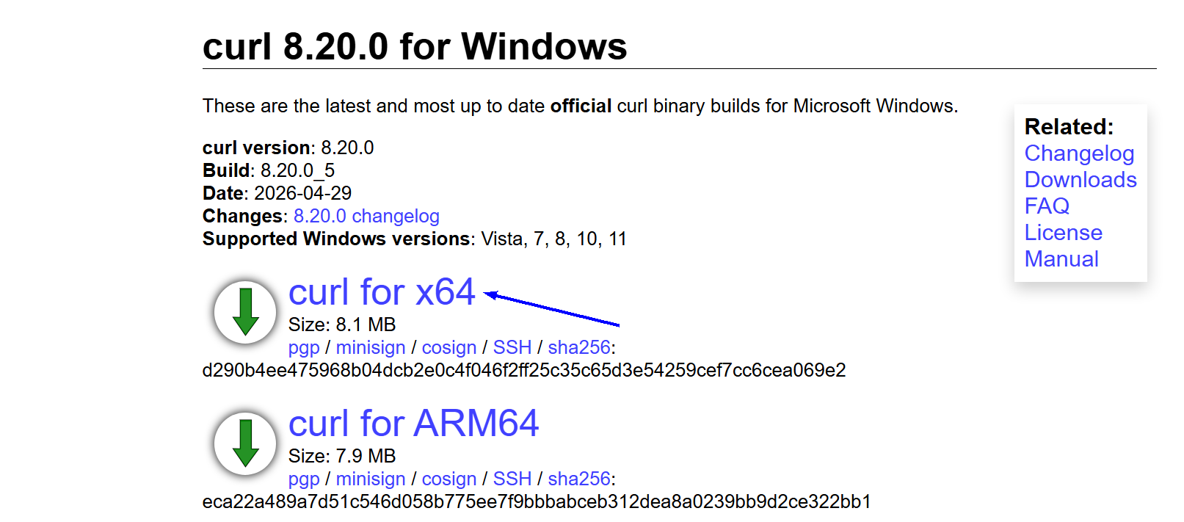

Install cURL
# Source: ScreenShot Source: Provided by: [Persons Table -> ID Column: 1, Name_En Column: Motasem Essam] -> Tool: [Automation Table -> ID Column: 16, Name_En Column: Screen Capture] -> From [Operating System: Windows] on [6/1/2026]

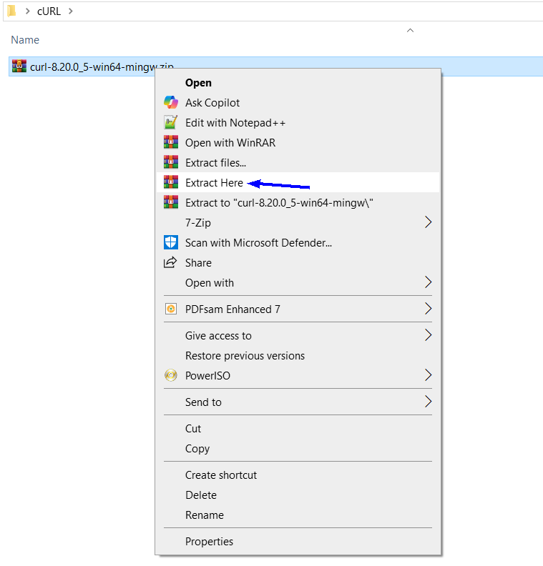
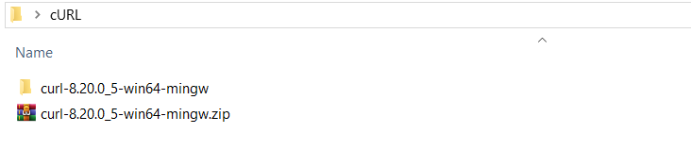
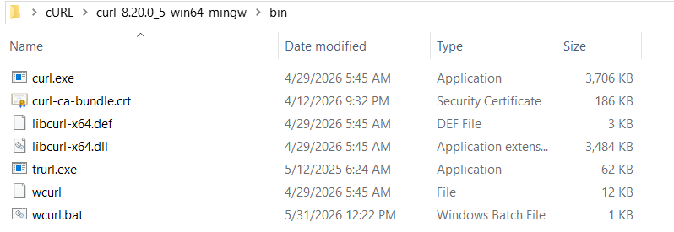

Add it to your System PATH
# Source: ScreenShot Source: Provided by: [Persons Table -> ID Column: 1, Name_En Column: Motasem Essam] -> Tool: [Automation Table -> ID Column: 16, Name_En Column: Screen Capture] -> From [Operating System: Windows] on [6/1/2026]
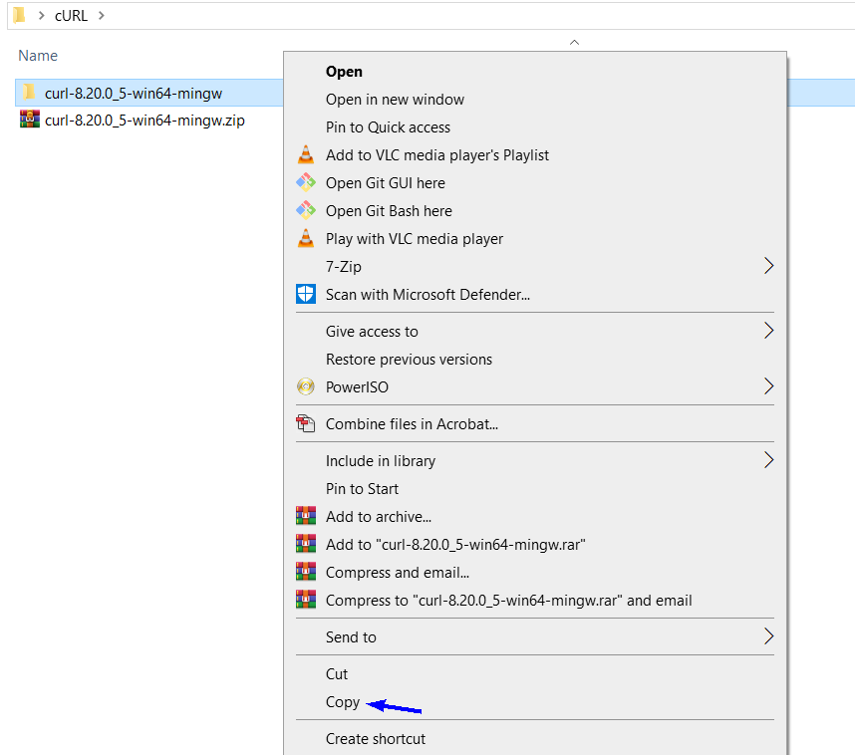
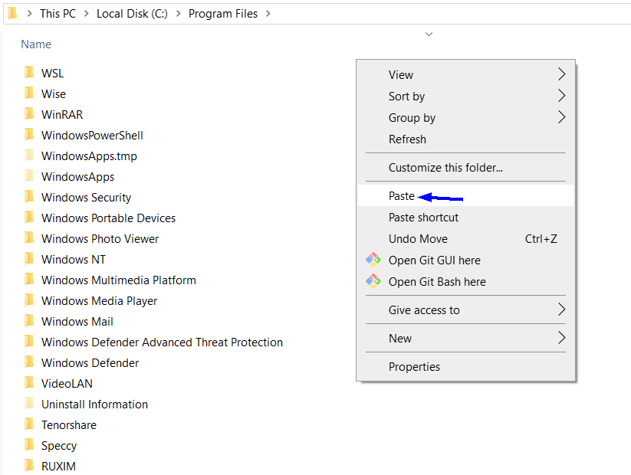
COPY THIS path
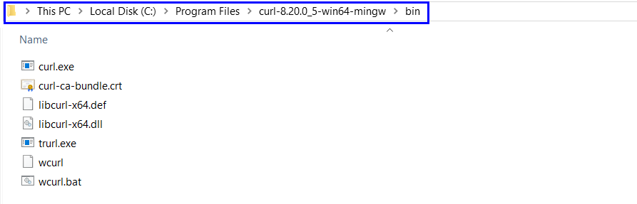
C:\Program Files\curl-8.20.0_5-win64-mingw\bin
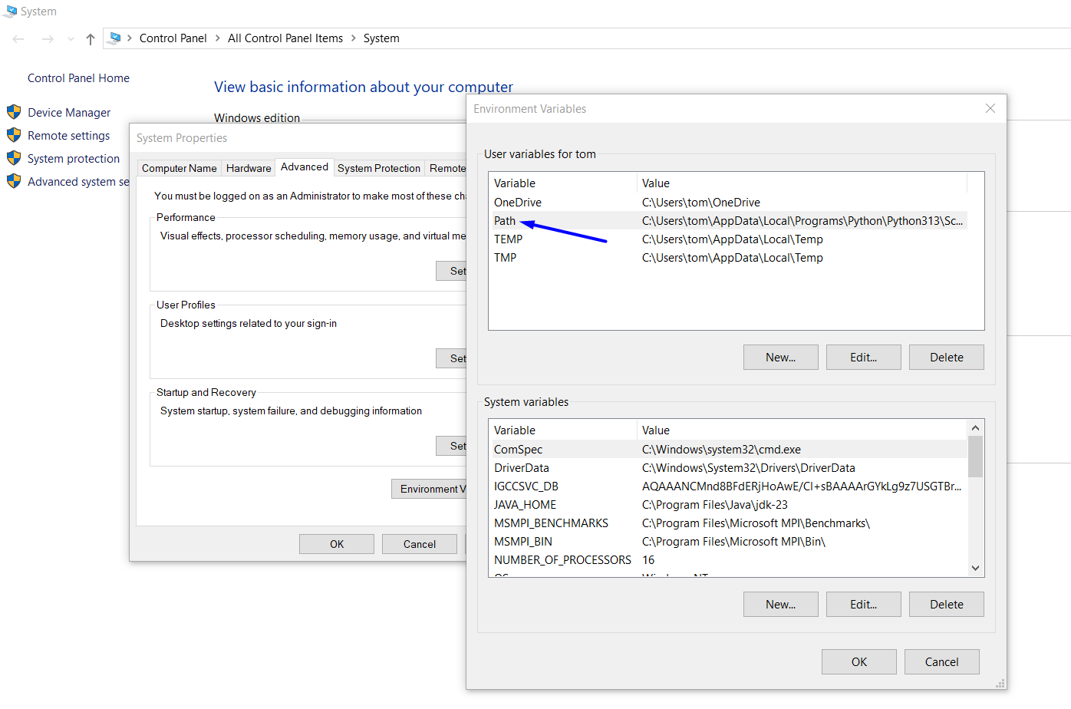

Paste path here
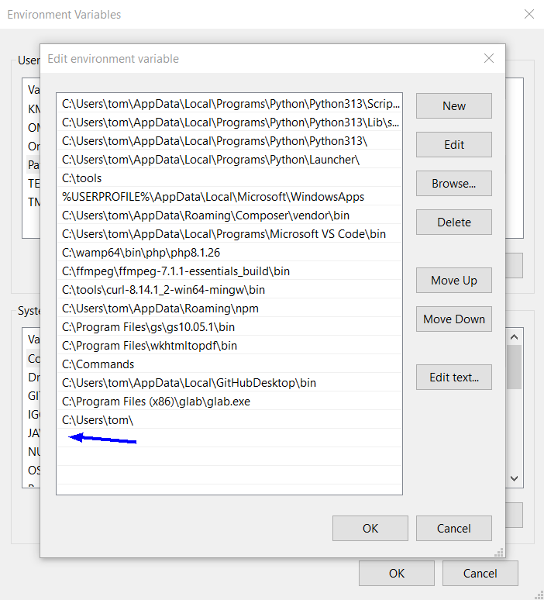
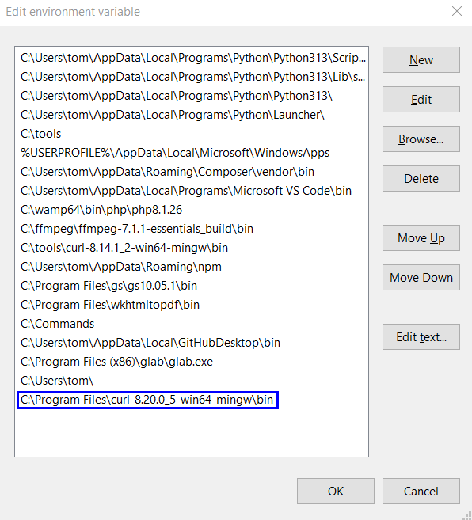

Run CURL
# Source: ScreenShot Source: Provided by: [Persons Table -> ID Column: 1, Name_En Column: Motasem Essam] -> Tool: [Automation Table -> ID Column: 16, Name_En Column: Screen Capture] -> From [Operating System: Windows] on [6/1/2026]
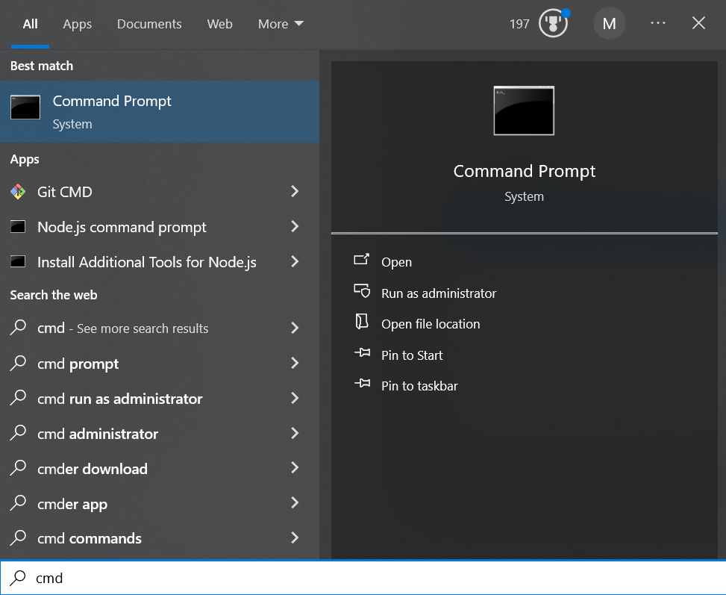
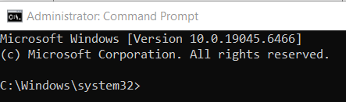
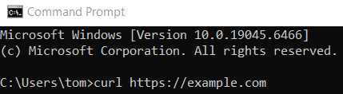
curl https://example.com
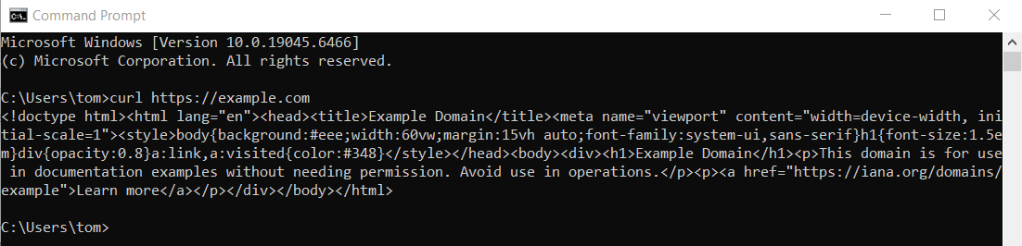

🧭 Summary
# Source: AI Source: Provided by: [Data Path: Persons Table -> ID Column: 1, Name_En Column: Motasem Essam] -> From: [ChatGPT] on [6/1/2026]
cURL is a command-line API and network communication tool used to send HTTP requests, test REST APIs, download files, upload data, authenticate with servers, and automate web interactions. It is one of the most widely used tools in API development, testing, and system administration.

